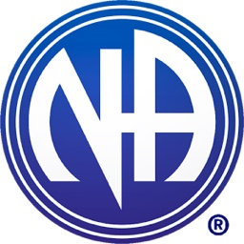

**Narcotics Anonymous**

Dear Sir/Madam,

We at Sussex Area Public Relations of Narcotics Anonymous are reaching out to local organisations/service providers to let you know what we can offer to you, your staff and your service users.

Our ‘Myths and Realities’ presentation aims to provide clear and accurate information so you can gain an insight to how N.A works in the lives of Addicts – locally, nationally and globally.  
We would also be happy to facilitate a *‘Gold fish bowl’* i.e mock meeting at your premises, which will allow your staff and/or service users to gain an understanding of how our meetings function as well as the opportunity to ask questions. We can also provide a staffed stand for any information days/events you might be planning, where NA members will be available to answer any questions, as well as handing out literature and information re local meetings.

If any of the above may be of interest, or if you have any questions or require further information, then please do not hesitate to contact us via the following:

email: **lsc@sussexna.org**

Local area website: **www.sussexna.org**  
(Where you can find details of meetings in your area)

National website: **www.ukna.org**  
(Where you can find details of meetings all over the country)

National Helpline: **0300 9991212**

