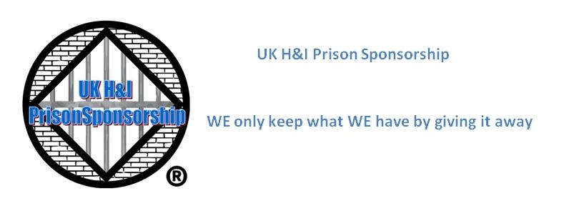

**Post Person And Sponsor Liaison Report April 2020**

**Postbag:**Only two postbags this month, next month we will only get one, unless the lockdown is lifted.

**Post Log:**

**Sponsor Liaison:**   
3 enquires.  
3 questions sent.  
1 ratified.  
All male.  
Any female enquiries are being referred to Distance Sponsorship.  
Follow-ups sent to the end of March.  
Can we ask UK H&I to announce at Region that we need male sponsors please?  
  
**Expenses:**100 x 1st class stamps £69.06  
  
**Basic Texts:**The Basic Text scheme has been suspended.   
  
**Other Busines:**  
All three email account passwords have been passed on to Resource; this includes an old yahoo account which is for archive purposes only.

Emails have been sent to all our female sponsors to inform them that Distance Sponsorship are looking for female sponsors.

Yours in Service  
Seamus  
UK H&I Prison Sponsorship Post Person/Sponsor Liaison

**Seamus O'Keeffe <okseamus@gmail.com>**



# Receipt for your payment

1 message

**service@paypal.co.uk** <service@paypal.co.uk> 30 April 2020 at 08:36

To: SEAMUS O'KEEFFE <okseamus@gmail.com>

30 Apr 2020 08:31:19 BST

Transaction ID: [16710912UW1923634](https://www.paypal.com/myaccount/transaction/details/16710912UW1923634?utm_source=unp&utm_medium=email&utm_campaign=PPX000608&utm_unptid=9962635e-8ab4-11ea-81fc-b875c0c3c09f&ppid=PPX000608&cnac=GB&rsta=en_GB&cust=2V531698GR9371832&unptid=9962635e-8ab4-11ea-81fc-b875c0c3c09f&calc=8685d3b1eea7e&unp_tpcid=email-receipt-auction-payment&page=main:email:PPX000608:::&pgrp=main:email&e=cl&mchn=em&s=ci&mail=sys&xt=Ctrl_EmailConfirmation_FooterUpdate)

**Hello SEAMUS O'KEEFFE,**

**You sent a payment of £69.06 GBP**

We've asked the seller to ship.

Thanks for using PayPal. To see all the transaction details, log in to your PayPal account.

It may take a few moments for this transaction to appear in your account.

|  |  |
| --- | --- |
| **Seller** | **Note to seller**  You haven't included a note. |
| **Delivery address –** confirmed  SEAMUS O'KEEFFE  [2 Shire Place](https://www.google.com/maps/search/2+Shire+Place+Northampton,+Northamptonshire+NN3+8DE+United+Kingdom?entry=gmail&source=g) | **Dispatch details**  The seller hasn’t provided any dispatch details yet. |

[Northampton,Northamptonshire](https://www.google.com/maps/search/2+Shire+Place+Northampton,+Northamptonshire+NN3+8DE+United+Kingdom?entry=gmail&source=g)

[NN3 8DE](https://www.google.com/maps/search/2+Shire+Place+Northampton,+Northamptonshire+NN3+8DE+United+Kingdom?entry=gmail&source=g)

[United Kingdom](https://www.google.com/maps/search/2+Shire+Place+Northampton,+Northamptonshire+NN3+8DE+United+Kingdom?entry=gmail&source=g)

|  |  |  |
| --- | --- | --- |
| Description | Unit price Qty | Amount |
| [Sheet of 100 x Royal Mail 1st / First Class Self](http://cgi.ebay.co.uk/ws/eBayISAPI.dll?ViewItem&item=143572374120&utm_source=unp&utm_medium=email&utm_campaign=PPX000608&utm_unptid=9962635e-8ab4-11ea-81fc-b875c0c3c09f&ppid=PPX000608&cnac=GB&rsta=en_GB&cust=2V531698GR9371832&unptid=9962635e-8ab4-11ea-81fc-b875c0c3c09f&calc=8685d3b1eea7e&unp_tpcid=email-receipt-auction-payment&page=main:email:PPX000608:::&pgrp=main:email&e=cl&mchn=em&s=ci&mail=sys&xt=Ctrl_EmailConfirmation_FooterUpdate)  [Adhesive Stamps](http://cgi.ebay.co.uk/ws/eBayISAPI.dll?ViewItem&item=143572374120&utm_source=unp&utm_medium=email&utm_campaign=PPX000608&utm_unptid=9962635e-8ab4-11ea-81fc-b875c0c3c09f&ppid=PPX000608&cnac=GB&rsta=en_GB&cust=2V531698GR9371832&unptid=9962635e-8ab4-11ea-81fc-b875c0c3c09f&calc=8685d3b1eea7e&unp_tpcid=email-receipt-auction-payment&page=main:email:PPX000608:::&pgrp=main:email&e=cl&mchn=em&s=ci&mail=sys&xt=Ctrl_EmailConfirmation_FooterUpdate)  Item Number 143572374120 | £67.00 GBP 1 | £67.00 GBP |
|  | Postage and packaging | £2.06 GBP |
|  | Insurance - not offered | ---- |
|  | **Total** | £69.06 GBP |