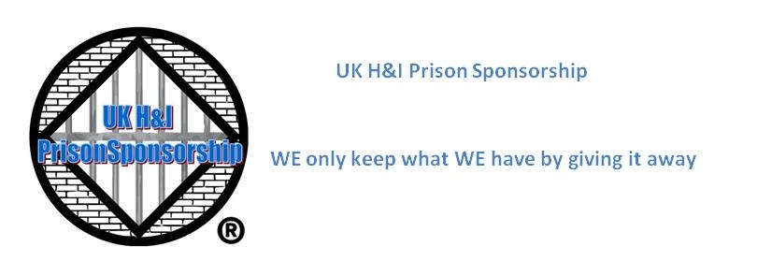

**Post Persons Report April 2021**

**Post Log:**

|  |  |  |  |  |  |  |  |  |  |
| --- | --- | --- | --- | --- | --- | --- | --- | --- | --- |
|  | **Letters To Sponsors** | | **Info Requests** | | **Sponsors Allocated** | | **Basic Text Requests** | **SWG's Requests** | **Institutions Affected** |
| **Date** | **Male** | **Female** | **Male** | **Female** | **Male** | **Female** |
| **03/04/21** | **1** | **1** | **5** | **1** | **5** | **1** | **3** | **0** | **14** |
| **10/04/21** | **5** | **0** | **1** | **0** | **0** | **0** | **0** | **0** | **6** |
| **21/04/21** | **6** | **2** | **2** | **1** | **2** | **0** | **4** | **1** | **14** |
| **23/04/21** | **4** | **1** | **1** | **0** | **1** | **1** | **2** | **0** | **0** |
|  |  |  |  |  |  |  |  |  |  |
| **Totals** | **16** | **4** | **9** | **2** | **8** | **2** | **9** | **1** |  |

**Postbag:**Month to month stats:

|  |  |  |  |
| --- | --- | --- | --- |
| **Men** |  |  |  |
|  | Letter to Sponsors | Info  Requests | Sponsors Allocated |
| January | 5 | 16 | 2 |
| February | 19 | 29 | 14 |
| March | 8 | 22 | 11 |
| April | 16 | 9 | 8 |

|  |  |  |  |
| --- | --- | --- | --- |
| **Women** |  |  |  |
|  | Letter to Sponsors | Info  Requests | Sponsors Allocated |
| January | 2 | 1 | 2 |
| February | 1 | 6 | 3 |
| March | 2 | 1 | 2 |
| April | 4 | 2 | 2 |

Of note we had 1 female contact us for a sponsor who had first contacted us 5 years ago.

I had to pay for the mailing of 1 step working guide at a cost of £3.20. Receipt will be provided by email/whatsapp  
  
Yours in Service  
Jane , John and Ellis  
UK Prison Sponsorship Post People