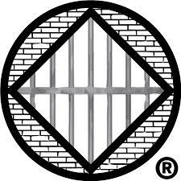
UK NA Prison Sponsorship

WE only keep what WE have by giving it away

Sponsor Liaison Report April 2021
Ratification:
3 enquires and questions sent.
2 ratified.
3 follow up emails sent for March.
Any female enquiries are being referred to Distance Sponsorship.
Can we announce at Region that we need male sponsors please?
Sponsor Inventory:
We have 9 sponsors that have failed to respond to numerous attempts to contact them. I propose that we remove them from the database, in line with GDPR.
Yours in Service
Seamus
UK Prison Sponsorship Sponsor Liaison

