**UK website audio share guidelines**

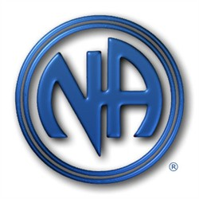To the group committee,

We invite you to send in shares from your meeting, event to spread the Narcotics Anonymous message that we do recover. We do however have to keep the message N.A focused. In order for your shares to be uploaded to the UK website we have members of the share review committee listen to and vote upon several guidelines which have been set up by trusted servants within Narcotics Anonymous.

* Does the speaker use NA language not that of other fellowships or treatment facilities? Including, but not limited to our Clarity Statement...
* *We are presented with a dilemma; when NA members identify themselves as addicts and alcoholics, or talk about living clean and sober, the clarity of the NA message is blurred. To speak in this manner suggests that there are two diseases, that one drug*

*is somehow separate from the rest, requiring special recognition. Narcotics anonymous makes no distinction between drugs. Our identification as addicts is all-inclusive, which allows us to concentrate on our similarities, not our differences.*

* Do they endorse or make reference to outside organisations, treatment facilities, counsellors etc?
* Do they mention others by full name?
* Is the language used acceptable i.e. free from vulgarity, discrimination or derogatory remarks?
* Is there excessive swearing? (we do have a disclaimer on the shares page of the website that does (explain that some people may find some of the language used offensive).
* Is it pertinent to practising the 12 steps?
* Do they share personal experiences or tell us how to recover?
* Is the recording quality acceptable and complete. This is important as some have been rejected due to bad sound quality?

And finally, if all the criteria are met, do we think that if the share were to be sold and not uploaded

for free on the NA Website, the person purchasing the share, feel that they had value for money?

If a share has a majority vote of rejection then the share will be removed from the ukna.org

website and not be available for any listener.

Any queries, please don’t hesitate to contact the share review committee.

[shares@ukna.org](mailto:shares@ukna.org)

In Loving Service,

Share review committee